Dessa Shapiro

Period 7

2/1/21

Making reality fantastical

A beam of luminescence pierces the skin of my eyelids, indicating my brain has been charged to its full capacity and I must open my visual devices and face my now countiouse senses. I test my body's rotation noticing the small cracks of joints, and the pull of muscle. I take a moment to rest my hand on my neck and feel the faint pulse providing me with function, movement. I take a moment to gaze at my lilac walls, I've never enjoyed the color but I find myself engulfed within the shadow created by a sliver of sunlight peeking through the adgar curtain. I'm able to notice the softness of the shadows and the way light refracts off the glass door knob, creating small prisms of light. With a sudden clarady and the focus of my eyes returning I snap back into my body sending goosebumps down my arms, and I start to feel heavy now that I have returned. Weighted down by the mass of blood and bone that exists with matter, I curve my findings to my palm in hopes that the feeling of my fingernails digging into my palm will clear my mind. I feel as if a clear film is placed over my eyes and decide to continue my day. I continue through my mundane routines, numbly moving through the surrounding air but pondering the point, What was I doing today? Well, whatever it may be, I have plenty of time to enter my portal, and escape for my mind for an unspecified amount of time. I unplugged my portal from its charging stations and type in my 20 digit code, it may seem like an unreasonable precaution but I keep it that long as a test of my sanity. For, how could I prove my reality without proof in this physical world. As soon as screen lights illuminated to a preset amount I'm immersed in a completely virtual reality. A reality connected to millions of other beings and endless information and creation, I wonder if I were to stare hard enough would I be able to see endless pairs of eyes staring back. But instead of directing my focus towards others I think it a better alternative to lose myself in fiction. It's as if there are overlapping dimensions, one into a virtual world and another into a world of stories where everything and anything can be created with one's own interpretation. Who's to say that our imaginations are not a separate dimension, one we pull thoughts and ideas out of. Or maybe each time I start and finish a new story a part of me is forever lost within that dimension. There are always so many questions revolving or chaotically bouncing off my mental walls. So, I continue moving through my day, physically confined by gravity but mentally floating through space, with no comprehensible destination.

Who am I?

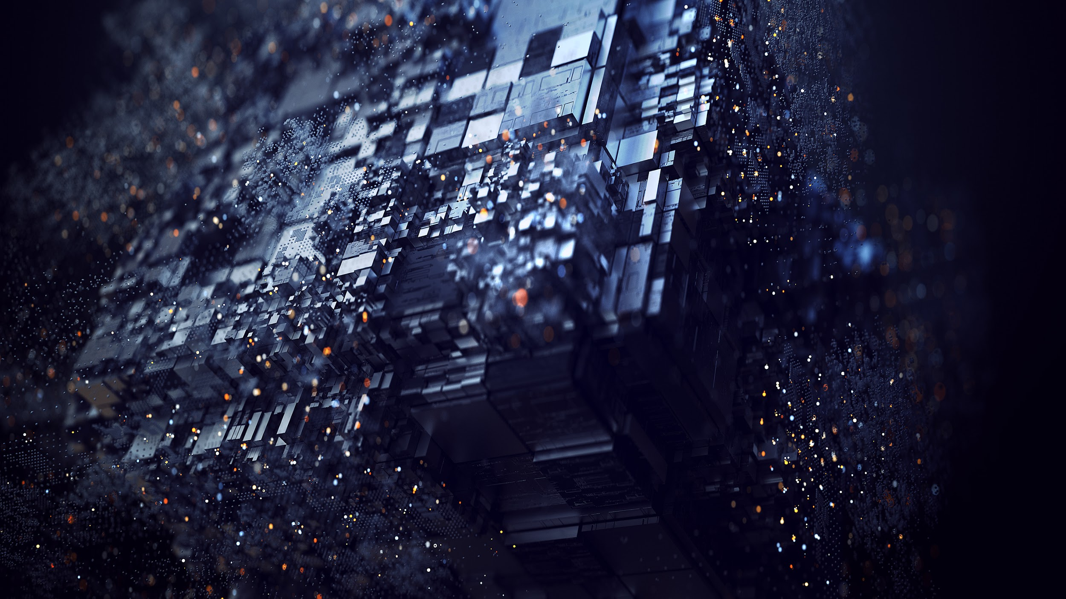

Reality is merely an illusion, albeit a very persistent one

- Albert Einstein